**Error Validating Address**

**Issue:**

**Description:** No match segment for MIS Account and Bill , error code 20 while submitting the ABR SR(TT# 235185484)

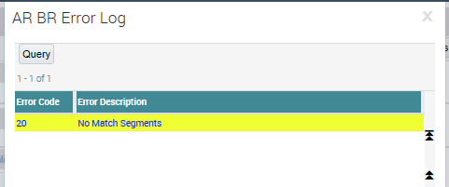

**Troubleshoot:**

Go to ABR SR, Drill down on ABR, under SR Details in Billing Address/FRP MVG, Take Billing Address 1

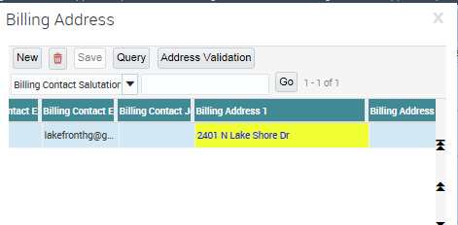

**Resolution:**

Billing Address 1- **2401 N Lake Shore Dr**

find **CustAddrValidationService** logs using this address and check for the error code in the response from GCP

**findit CustAddrValidationService '2401 N Lake Shore Dr' 90**

<http://zlpv7059.vci.att.com:2220/RWS_out/CustAddrValidationService/20170823_165156_EMPTY_1249_PSReq.xml>

http://zlpv7059.vci.att.com:2220/RWS_out/CustAddrValidationService/20170823_165156_EMPTY_1249_PSResp.xml

<tns:AddressValidErrorCode>Q</tns:AddressValidErrorCode>

<tns:ReturnCode>20</tns:ReturnCode>

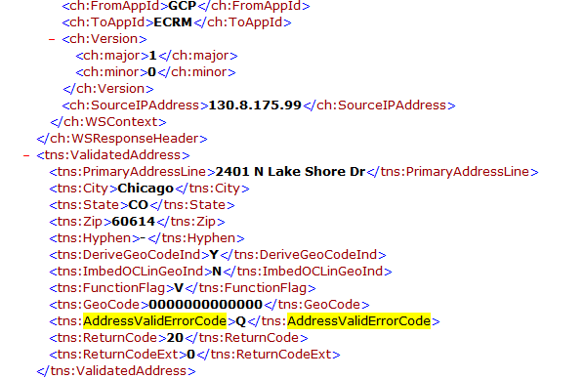

In the response, you will see ErrorCode from GCP depending upon the error you are getting on SR..

Provide above logs to GCP asking why they are giving this error.

**Validation:**

GCP gets this error code from Group1 and Group1 validates only US addresses present in USPS

If USPS don't have the address, then Group1 won't have that address at all**.**

As per GCP,

Bobby Keith(8:36:07 PM): <v1:AddressValidErrorCode>Q</v1:AddressValidErrorCode>

Bobby Keith(8:36:15 PM): thats the error code they gave back

Bobby Keith(8:36:59 PM): This is what the error codes mean that Group1 (CTM ABS) can return

Bobby Keith(8:37:01 PM):

'B' Insufficient data for match

'H' House not found on street

'M' Multiple matches

'S' Street not found in zip code

'X' Group1 Data has expired

'Z' Zip Code not found

**'Q' No Match Segments**

space OK, match found

Bobby Keith(8:37:43 PM): that means nothing in the address was found

Bobby Keith(8:38:52 PM): also you can verify if USPS has an address by using their website

Bobby Keith(8:38:59 PM): so even they don't have this address

Bobby Keith(8:39:10 PM): if they don't then Group1 (CTM ABS) won't have it either

Bobby Keith(8:39:21 PM): https://tools.usps.com/go/ZipLookupAction_input

Bobby Keith(8:40:02 PM): the user should see if there is another address they can use and they should verify it in USPS first.

So user needs to check for another address which they can use further.

**More Reference Tickets#:**

233809419

234378912

235176715

235213715